Lessons for Titan balloons from recent terrestrial experience

Julian Nott⁽¹⁾, Don Cameron⁽²⁾, Bruce Comstock⁽³⁾, Kevin Uliassi⁽⁴⁾

⁽¹⁾Nott Technology LLC, Santa Barbara, CA., USA 93108 *e-mail: nott@nott.com
⁽²⁾Cameron Balloons Ltd., St John's Street, Bristol, UK., BS3 4NH, dcameron@cameronballoons.co.uk
⁽³⁾ Bruce Comstock, BruceComstock@ix.netcom.com
⁽⁴⁾ Kevin Uliassi, Principal at K. Uliassi, Architect, Phoenix Arizona, USA, LZ130@cox.net

ABSTRACT

Saturn's moon Titan is now widely considered to be an extremely interesting Solar System science destination. Balloons appear ideal for exploring Titan. Especially in the late 1990's huge efforts were made to around the world by balloon. This paper attempts to discover lessons from this effort relevant to general balloon design and Titan balloons in particular. One important part of this effort was the Comstock Autopilot, very relevant to Titan and this paper includes observations by Kevin Uliassi from his flights.

1. INTRODUCTION

Shortly after the Cassini-Huygens probe started orbiting in the Saturn System, it became obvious that its moon, Titan, is a fascinating destination. Cassini has now flown by Titan 85 times [August 2012] and interest grows with every pass. If nothing else, witness the time and effort devoted to Titan at this IPPW.

Balloons appear to be excellent vehicles to explore Titan. Firstly Titan has uniquely good conditions for balloons compared to anywhere else in the Solar System. The most important factor that limits terrestrial balloon life is the day/night change in solar heating, a thousand times less on Titan. The second factor is ultraviolet balloon degradation, down by a factor of more than 1,000. Thus the two most important factors that limit balloon life on Earth disappear. Most other factors are significantly better.

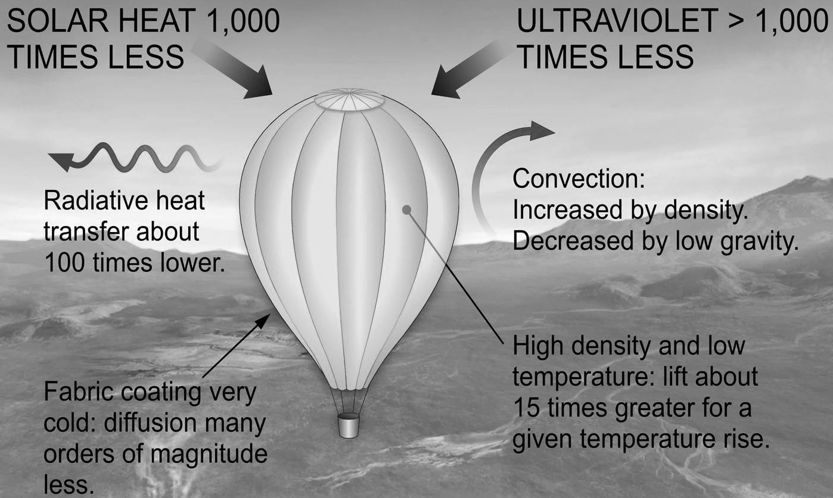

Fig. 1Titan's ideal conditions for balloons.

The great advantage of balloons over Rovers is the ability to go anywhere. Some of the most interesting places on Titan are likely to be its methane/ethane lakes and seas and the shores. Note the balloon in Fig. 2 is shown crossing the shore, totally inaccessible to a Rover on wheels. Depending on weather conditions, a Titan balloon could fly from a few meters above the surface to many kilometers. This allows perspectives quite hidden to a surface Rover. There is speculation that "Weird Life" might exist on Titan. It is impossible to know what scale it might have. From tiny to giant, a Titan balloon can fly at an altitude to observe it.

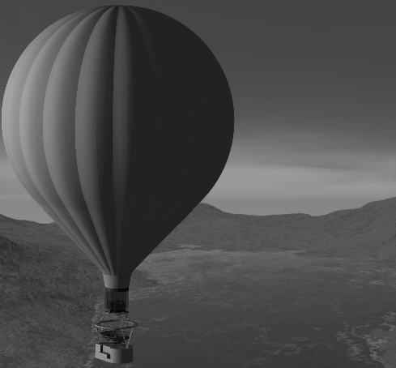

Fig. 2 Titan balloon conception courtesy Tibor Ballint.

2. INTENTION OF THIS PAPER

After the Atlantic was crossed by balloon in 1978 by Abruzzo and Anderson, the immediate reaction was that "The Last Great Balloon Adventure" had been completed and there was nothing left to do. But this sentiment did not last long. An ever increasing number of attempts were made to fly around the world from the early 1980s. Indeed it evolved into a wild "Race to be first around ".

It is impossible to quantify exactly how much was spent on these numerous attempts. Some participants no doubt exaggerated for effect, while other sponsors with an eye to their shareholders may have minimized their expenditure or refuse to disclose it at all. But a reasonable estimate is that $50 million to 100 million. This was unprecedented in balloon history.

The inspiration for this paper came from Dr. Jeffrey L. Hall of the NASA Jet Propulsion Laboratory. He suggested that much might be learned from "The Race" which would be useful for all balloon design and Titan balloon design in particular.

Moreover this knowledge is rapidly evaporating with time and because several participants have died from natural causes or flying accidents.

Understanding heat transfer is perhaps the single most important factor in understanding balloon behavior. In particular it was expected there would plenty of useful information about heat transfer. This did not turn out to be the case. Firstly, although a lot of participants gave lip service to science, for many participants the focus was celebrity and publicity. Secondly heat transfer is difficult to estimate. Nearly all the balloons where combined helium and hot air balloon, Roziers, see below. It is difficult to know at any time exactly how much load is being carried by helium and how much by hot air. In addition, the weight of the craft is changing continuously as propane fuel is burned, and in some cases as ice accumulated from water vapor produced in combustion. Typically fuel was about 60% of the total weight at takeoff so the change in weight was substantial.

But even if the lessons were not those expected, this does not for a moment mean there is not much to learn.
IMPORTANCE OF BALLOONS TO SCIENCE

Balloons might be thought antiquated for 21 century Titan exploration. But they have continuously advanced and always made major contributions to science since they were invented. Their use in contemporary science shows their relevance for Titan.

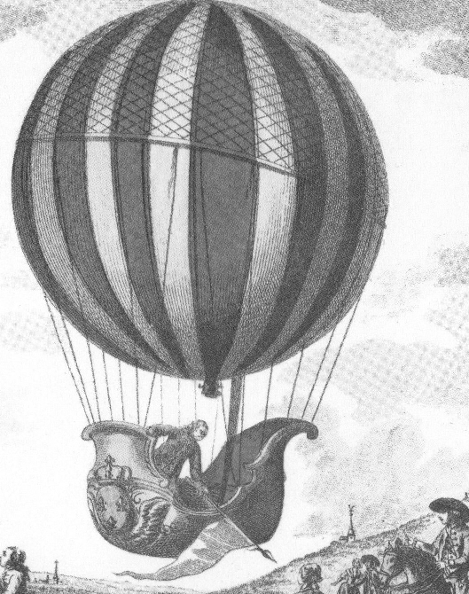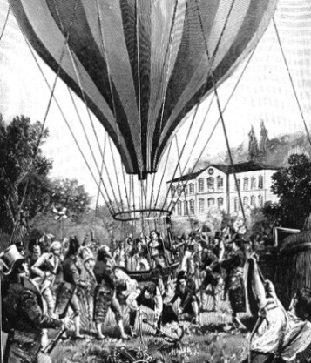

Fig 3. 18th century, Professor Charles, 19th century Gay-Lussac

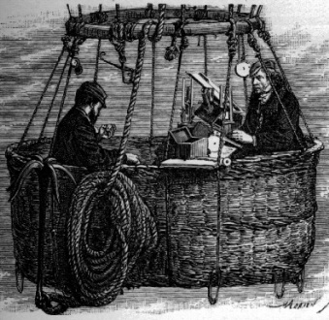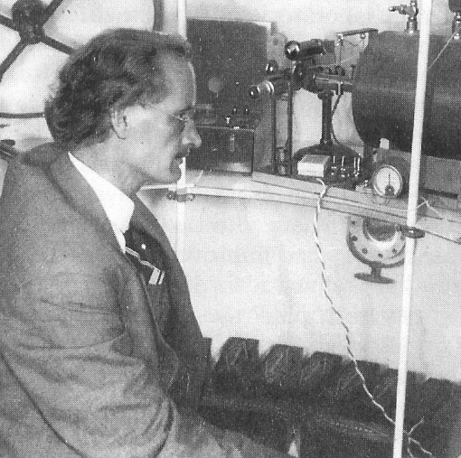

Fig. 4 19th century Glaisher, 20th century Piccard

At the very start, two of the three gas laws, Charles Law and Gay-Lussac's Law, were only recognized after their respective authors had flown in their balloons.

In the 19th century balloons were the only way to explore the atmosphere, notably used by Glaisher, "The First Scientific Balloonist", who meticulously observed the atmosphere. In the 20th century, far from being antiquated, balloons allowed August Piccard to study cosmic rays in a pressure cabin flying at record altitude higher than any contemporary aircraft.

And in the twenty first century, with decline in some space research budgets high altitude balloons are actually enjoying increased use and routinely take large science experiments weighing several tons to the top few percent of the atmosphere.

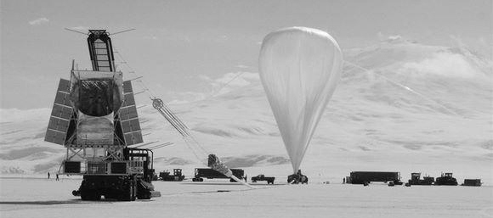

Fig. 5. 21 century: BLAST Large Submillimeter Telescope launching to the top of the atmosphere.

THE HISTORY OF BALLOON ADVENTURE

As mentioned, some people might consider balloons to be an anachronism, but not in the least. Sport balloons have evolved just as much as those for science, equally helped by improved materials and understanding of weather. Balloons do not look like going out of fashion any time soon. Like small boats their abilities are limited, but they are similarly simple, inexpensive have a long history boats will hardly disappear soon.

Flying around the world does not stand alone but rather was a logical extension of everything that came before, notably attempts to fly the Atlantic.
In the earliest days, it was amazing enough that flight was possible at all. Balloons were used for public spectacles such as Pierre Testu-Brissy numerous flights on horseback, Fig. 6. That said, Gay-Lussac made a scientific has ascent as early as 1804.

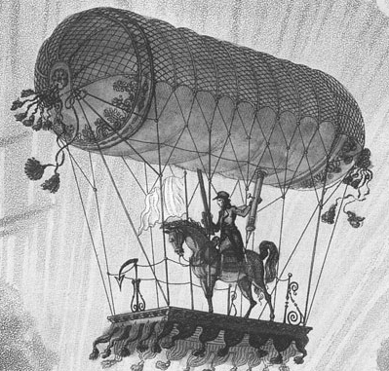

Fig. 6 Spectacle: Testu-Brissy on horseback 1798.

But over time, pilots became more adventurous. James Green in England made a remarkable flight from London to Germany in 1836, covering 378 miles in just 18 hours: as a measure of how remarkable this was the at the time, the return journey using contemporary transport methods took three weeks.

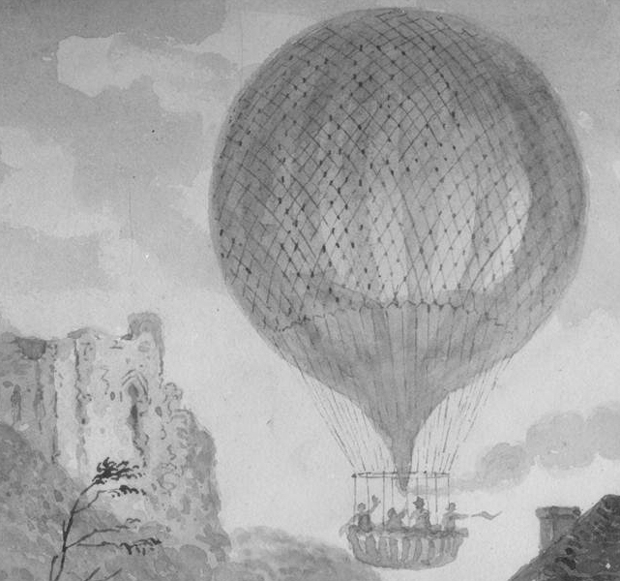

Fig. 7Green's remarkable 380 mile flight 1836

In the mid-19th century Thaddeus Lowe and John Wise, leading balloonist of their age made serious preparations to cross the Atlantic. [It took more than a hundred years till the flight was made]. They were derailed by the Civil War and lacked technology and understanding of weather. But shortcomings like this did not deter others such as Andrée who tried to reach the North Pole in 1897, Fig 8. Ironically the crew landed safely then died from eating polar bear meat.
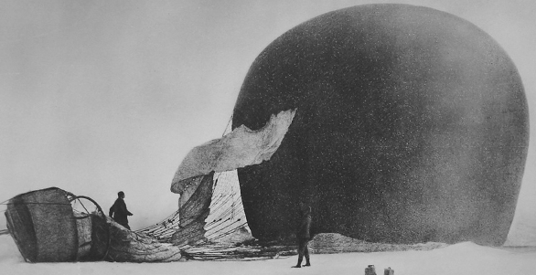
Fig. 8 Andrée 1897 "The saddest balloon disaster."

Until the Wright Brothers, balloons were the only way to fly. But airplanes caused interest in balloons to ebb. It only revived with Otto Winzen' s large polyethylene balloon in the 1950's: new material made huge advance possible. Interest in piloted ballooning revived dramatically with Ed Yost's invention of the nylon hot air balloon, again possible with improved fabrics and liquid propane. A rapid increase in the number of hot air balloon pilots lead to interest in all balloons and this culminated in attempts to fly the Atlantic.

As later with world flights, crossing the Atlantic became a competitive and sometime fatal race. In 1970 Malcolm Brighton and crew were lost without trace when "Free Life" went down in a storm.

In 1973, Bobby Sparks attempted the Atlantic in a combined helium / hot air balloon, "Yankee Zephyr", a reinvention of de Rozier's unfortunate "Tour de Calais" in which he died in 1785, Fig. 9.

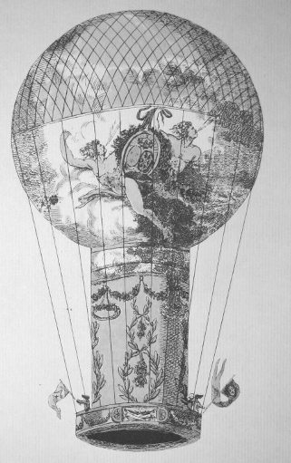 | Fig. 9 The first gas and hot air combination balloon built by Pilâtre de Rozier After whom the type is named.  De Rozier was killed flying this craft, the first fatal flying accident.

But Sparks was ahead of his time: there is a saying in motor racing that last year's technology perfected always beat the newest invention. Depending on how you count, there were fourteen attempts to cross the Atlantic. The first successful crossing was by Abruzzo and Anderson in 1978. They used a simple helium balloon, arguably "the perfection of last year's technology": indeed their record 137 hours is still unbroken for the type. Fig. 10. The heyday of the Rozier was still to come.

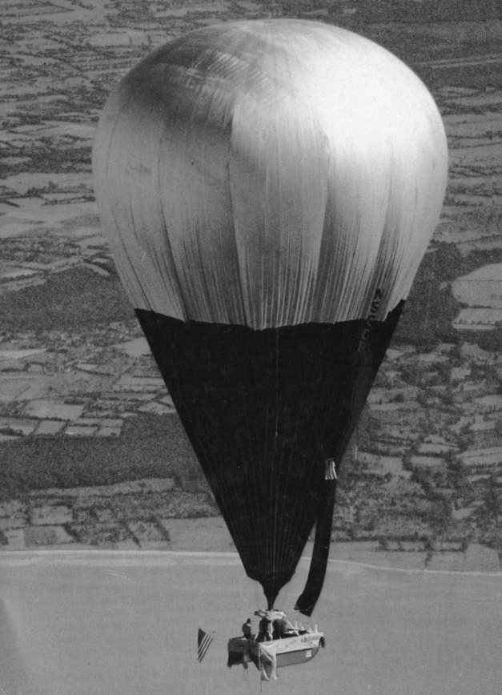 | Fig. 10. 1978 Atlantic Crossing by Abruzzo and Anderson, a seminal moment. The time aloft record of 137 hours still stands for the type.

The time, almost 6 days gives a benchmark of balloon capabilities before the Word Race. In the next 20 years, piloted balloon duration increased to 20 days.

ON TO THE WORLD

After the Atlantic crossing, one reaction was that this was "The Last Great Balloon Adventure" with nothing new to do. But this did not last as pilots soon announced plans to fly around the world. The earliest, such as Maxie Anderson, proposed stopping en route. But soon clear the prize everyone sought was a non-stop circumnavigation.

The first balloons to fly around the world were Vin Lally's tiny GHOST balloons in the 1960's by: one flew around the world 35 times non-stop. Perhaps this made piloted flights seem easier than subsequent events demonstrated.

TYPES

Arguably the first world attempt was by the Malcolm Forbes in 1975. He planned to fly from California to Europe under a cluster of GHOST balloons. He never stated he hoped to fly around the world, but obviously had it in mind. With lucky weather he might have succeeded but like so many record attempts he was thwarted at takeoff and never left Tustin Field.

Three types of balloons were developed specifically for world attempts. The first was Nott's pumpkin and second Larry Newman's "Sky Anchor" air ballast type Fig. 11. In the 1970's NCAR did extensive work on Sky Anchor balloons without any success. Both it and the Pumpkin have great theoretical advantage but practical craft have proved difficult.
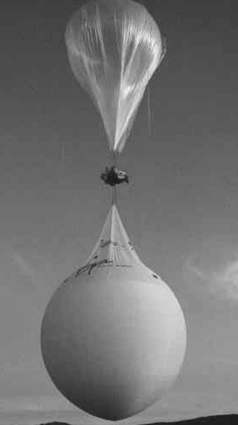 | Fig. 11. Earthwinds, perhaps $20 million was spent on five failed attempts 1992/4

Almost all world attempts used Rozier's substantially evolved from Sparks general arrangement with a helium cell inside a hot air balloon. An exception was John Petrehn's Operation S.H.A.R.E, Fig. 12 with one balloon above the other. All these combination balloons were large, cumbersome and expensive but the race was on, everyone was rushing and they worked.

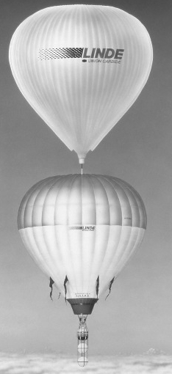 | Fig. 12. John Petrehn's Operation S.H.A.R.E

While Bob Sparks "Yankee Zephyr" had been ahead of its time for the Atlantic, a Rozier won the world race.

"The Race" evolved into a sometimes impetuous scramble. In the rush, numerous launches were aborted or flights abandoned shortly after takeoff. Several balloons landed in the ocean: coast guards worldwide were kept busy. Fig. 14 and Fig. 15.

In the fall of 1998, at least 20 world attempts been made, eight teams had announced plans for the winter and at least one other was preparing in secret.
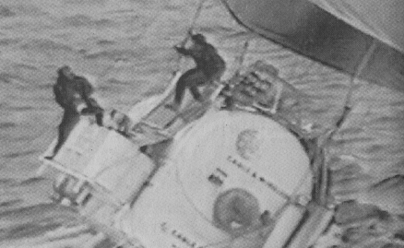
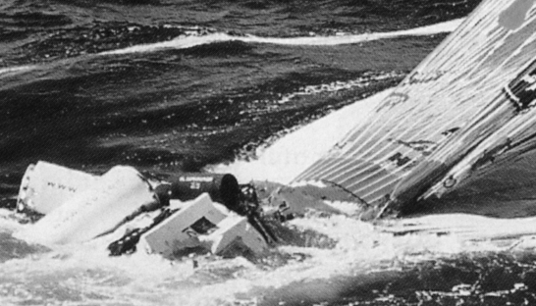

Fig. 14 and 15: multi-million dollar ditchings.

ULTIMATE SUCCESS

Fig. 15 Breitling 19 days 40,800 kilometers

After innumerable attempts over almost 20 years, the first piloted flight around the world was achieved in 1999by Breitling Orbiter III, that team's third attempt.

LESSONS

Despite the lack of qualitative data, there are numerous lessons for ballooning.

LESSON ONE: FORECASTING IS CRUCIAL

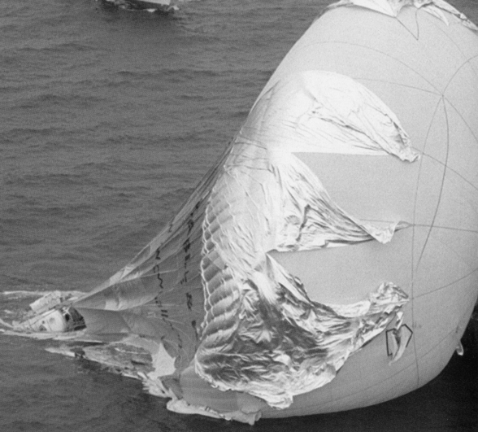

Fig. 16 Cable & Wireless 18 days 19,700 kilometers

Understanding the weather is everything. There is a sharp contrast between "Breitling III" and Cable and Wireless. These very similar balloons remained in the air for almost the same time, Fig. 15 and Fig. 16. Yet Breitling covered 41,000 kilometers while Cable and Wireless covered only 19,700. The crucial difference was understanding weather.

On a similar note, the first crossing of the Pacific by balloon covered a greater distance in substantially less time than the first Atlantic crossing. The average speed was three times greater: the Pacific crossing was a victory for forecasting, not for balloon design.

LESSON TWO: THE RIGHT FORECASTER

As is often the case, once a technical path to a particular objective has been found, the success if soon repeated. Thus the first solo flight was completed by Steve Fossett only two years after Breitling III, Fig. 17.

Fossett made no less than five failed attempts. Then he switched forecaster and worked with Luc Trullemans who had forecaster for Breitling's success. Fossett immediately flew around the world successfully. This flight showed that it is not enough to focus on forecasting, there are very few forecasters with the particular skill and it is important to choose careful.

AN IMPORTANT ANCILLARY LESSON

The Comstock Autopilot was crucial to Fossett's success. Hot air balloon autopilots are difficult to design because of the long time lag between using the burner and acceleration of the balloon. His insights are directly relevant to Titan. Arguably this autopilot is a very useful products of "The Race" with insight for autonomous control of any Titan hot air balloon. Details are attached in an appendix.

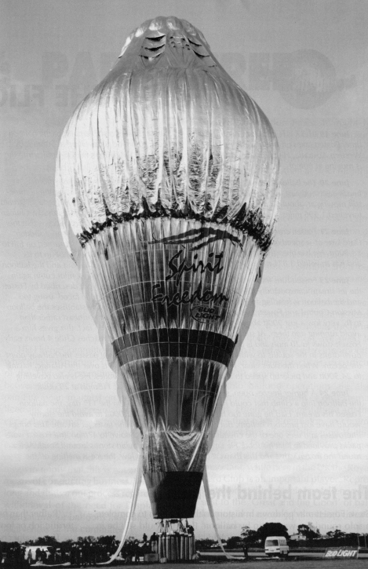

Fig. 17. Steve Fossett solo flight 2001

LESSON THREE: MULTI-LAYER BALLOONS

Complex balloons work. For world flights it was essential to minimize heat loss and various complex schemes were used. For world flights it was important to reduce the mass of propane fuel. For Titan balloons radioisotope heat sources are costly and in short supply: fabric costs much less than radioisotopes. Breitling was very successful burning only about 100 kilograms of fuel per 24 hours. Fig. 17.

But while the Breitling and Fossett balloons where complicated compared to other balloons, they went still very simple compared to even components of spacecraft. Some measure of the relative complexity of balloons and spacecraft is that 177 years elapsed between the first balloon flight and the first human spaceflight.

Cameron Balloon built the Breitling and Fossett craft, an outstanding contribution to balloon design.

LESSON FOUR: PILOT ATTITUDES

The bold attitudes in world flight were totally alien to typical experimental flying, a lesson in what not to do.

AND A POSTSCRIPT

Rozier balloons were not perfected in time to win the "Atlantic Race" but evolved to win around the world. Yet no large Rozier has been built since. And while the pumpkin was not perfected for World flights, a 19 million cubic foot version from the NASA Balloon Program Office will soon be available for science, to carry 2300 kilograms for 100 days at 110,000 feet / 33,000 meters. Fig. 18.

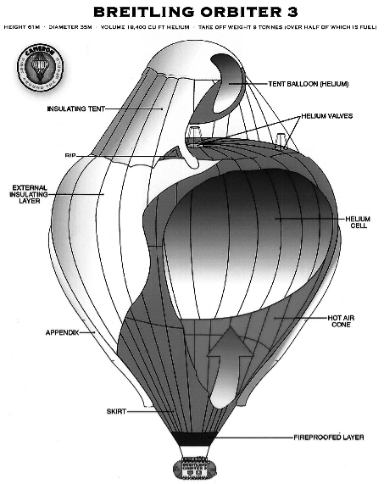

Fig. 17 Breitling Orbiter III multi-layer construction

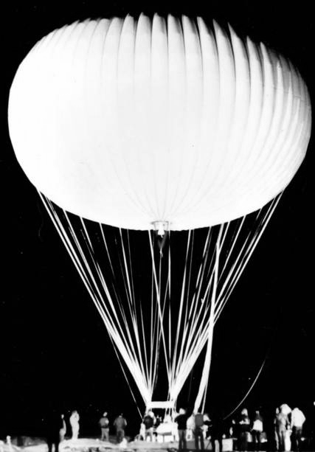 | 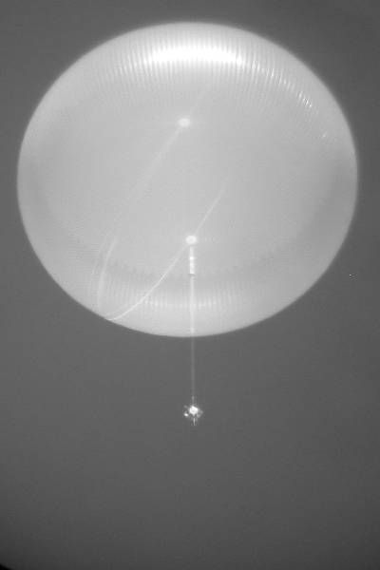
Fig. 18. Nott & NASA's superpressure pumpkins.

ACKNOWLEDGMENT AND THANKS

Particular thanks are due to Dr Jeffery L. Hall of the Jet Propulsion Laboratory, Pasadena, CA., USA, for both the inspiration and the funding for this paper.

